NATIONAL AI DAY

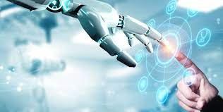

Artificial Intelligence is the intelligence possessed by the machines under which they can perform various functions with human help. With the help of A.I, machines will be able to learn, solve problems, plan things, think, etc. Artificial Intelligence, for example, is the simulation of human intelligence by machines. In the field of technology, Artificial Intelligence is evolving rapidly day by day and it is believed that in the near future, artificial intelligence is going to change human life very drastically and will most probably end all the crises of the world by sorting out the major problems.

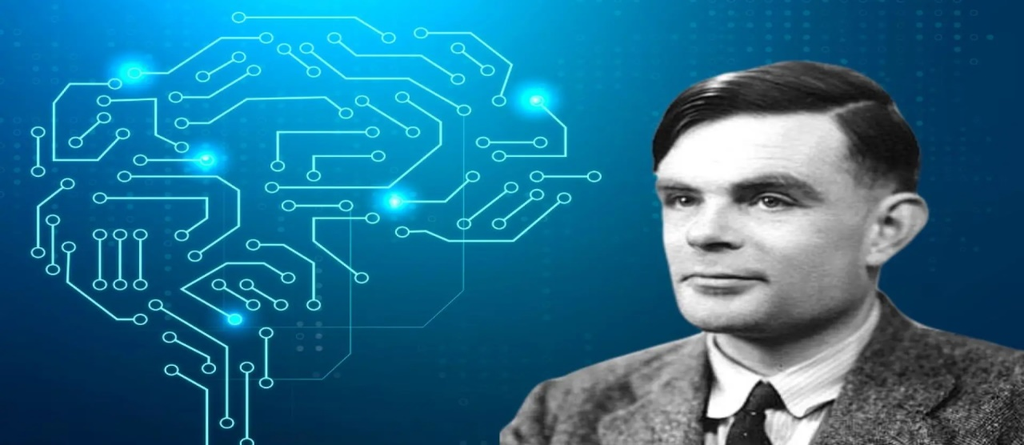



The earliest substantial work in the field of artificial intelligence was done in the mid-20th century by the British logician and computer pioneer [Alan Mathison Turing](https://www.britannica.com/biography/Alan-Turing). In 1935 Turing described an abstract computing [machine](https://www.britannica.com/technology/machine) consisting of a limitless memory and a scanner that moves back and forth through the [memory](https://www.britannica.com/technology/computer-memory), symbol by symbol, reading what it finds and writing further symbols. The actions of the scanner are dictated by a program of instructions that also is stored in the memory in the form of symbols

This National ‘Ai’ Day, celebrated on April 26, you’ll get to learn about the meaning behind this Chinese and Japanese word. ‘Ai’ means ‘adoration,’ ‘affection,’ or ‘love.’ The word is used almost exclusively as a female name in Japan, but boys are sometimes given it in Chinese too. Notable figures such as Ai Wei Wei, Ai Sugiyama, and Ai Otsuka share this name, and dozens of videogames, cartoons and fantasy characters with the name appear across Japanese and Chinese media. It’s pronounced similar to the word ‘eye’ in both cultures, but the kanji (Japanese) inscriptions differ from the hanzi (Chinese) characters.

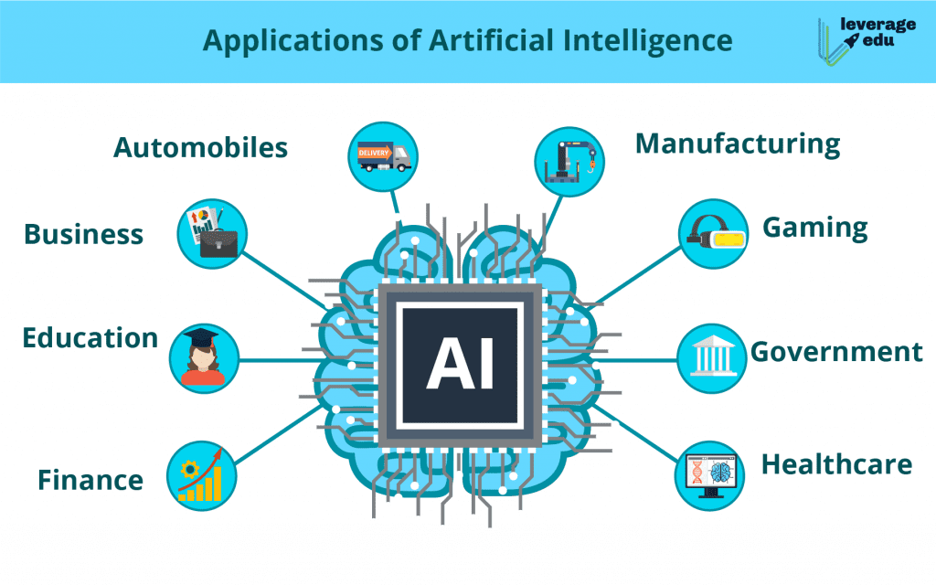

1. **Smart Home Devices:** With artificial intelligence, smart thermostats can automatically adjust your home’s HVAC system, while cameras can alert consumers to the presence of people, cars or packages.
2. **eCommerce:** AI is everywhere in online shopping. Notable applications include product suggestions, but also chatbots that can help manage sales and returns, alongside customized shopping experiences.
3. **Trend Identification in Retail:** Online stores aren’t just serving up recommendations when you shop, they’re actively using data on what’s selling – in their store and their competitors – to identify trends. They can use AI to design and manufacture so that the next big thing is ready and in stores when the public wants it.
4. **Content Recommendations:** AI-powered content recommendation engines are trained using product catalogs and consumer data to deliver more personalized recommendations.
5. **Navigation and Travel:** Paper maps are a thing of the past. AI-generated directions can optimize for travel time or fuel consumption.
6. **Drug Discovery:** By identifying their hazardous potential and mechanisms of action, AI systems are finding novel medication applications. This technology helped establish several drug discovery platforms that allow businesses to reuse current medications and bioactive substances.
7. **Facial Recognition to Unlock Phones:** You look at your phone, and it unlocks. These features are backed by an artificial intelligence that takes advantage of camera and sensor technology to accurately measure your face.
8. **Financial Fraud Detection:**AI is extremely good at pattern analysis, and it turns out that most of us use credit cards in a fairly predictable way. That makes it well suited for the task of determining which credit card transactions may be illicit. If you’ve ever gotten a call from your bank asking if you made a transaction, that was likely the result of AI.
9. **Autocorrect:**AI systems use machine learning, deep learning, and natural language processing to identify incorrect language usage in word processors, texting apps, and other textual media and provide corrections and suggestions.

